Inaugural Ceremony of President José Ramos-Horta and the 20th Anniversary of the Independence Day Celebration

Report from Timor-Leste Akiko ABE, The Global Peacebuilding Association of Japan 20 June 2022

Nobel Peace Prize laureate, Mr. José Ramos-Horta, was sworn in as President of Timor-Leste on 19 May 2022, ahead of the celebrations marking the 20th anniversary of independence for Asia’s newest country. President Horta called for political dialogue and stability among political leaders and citizens to achieve the top national priorities such as Education, Health, Agriculture, Food Security, Nutrition and Water, Transparency in the State among many others. He expressed his hope that Timor-Leste will become the 11th member of the Association of Southeast Asian Nations (ASEAN) in the next two years.
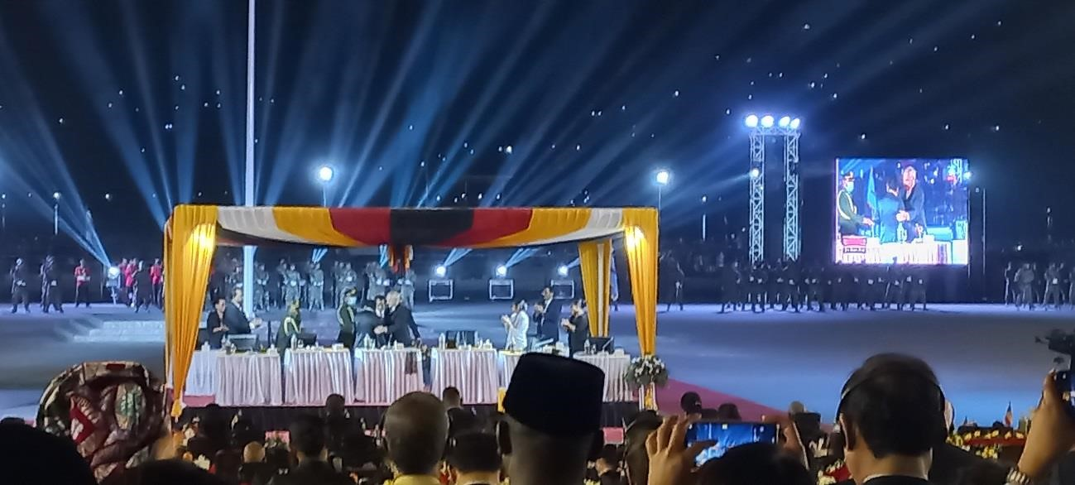
(Photo by Akiko Abe)

The Japanese civil society delegation led by Professor Sukehiro Hasegawa, former Special Representative of the Secretary-General of the United Nations, attended the inaugural ceremony of the President of the Democratic Republic of Timor-Leste and the Independence Day celebration events on 19 and 20 May 2022. The delegation included Professor Takaaki Mizuno of Kanda University of International Studies, Professor Mayumi Yamada of Ritsumeikan University,
Professor Takeshi Sato Daimon of Waseda University, Professor Juichi Inada of Senshu University and Ms. Akiko Abe of the Global Peacebuilding Association of Japan (GPAJ).
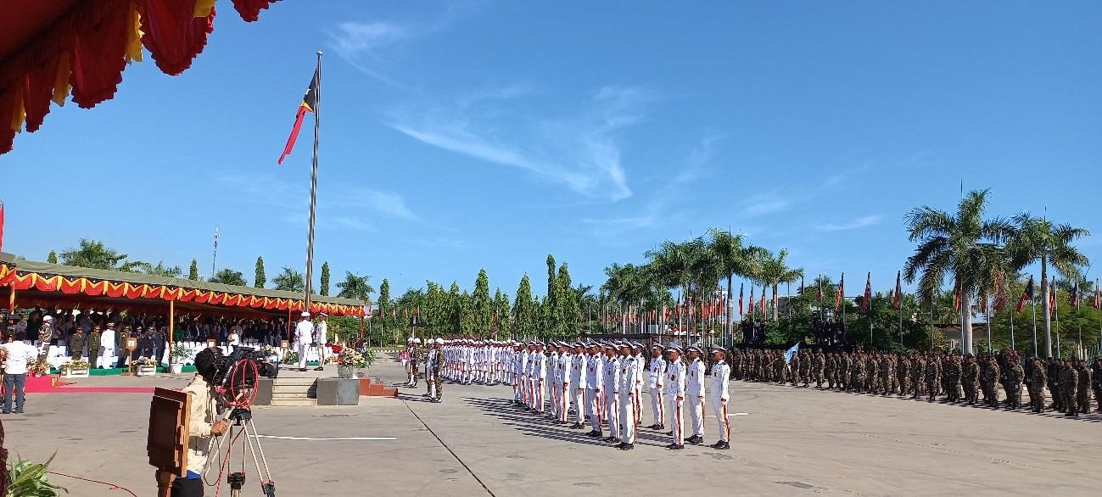

(Photo by Akiko Abe) Dialogue for World Peace and Security with President José Ramos-Horta
On May 21, Professor Hasegawa handed the report of the Evaluation of the Official Development Activities of Japan extended to Timor-Leste to President José Ramos-Horta. The President also expressed his appreciation for the support continuously extended to the people of Timor-Leste by the people of Japan. Professor Hasegawa also informed the President about the international dialogue he is conducting among various scholars and intellectuals about the implication of the War in Ukraine and the need for United Nations Security Reform. Professor Hasegawa emphasized the importance of the role of Timor-Leste led by the newly elected President José Ramos-Horta as the role model in promoting world peace emanating in this Asia-Pacific region. Continuing an open dialogue among various countries is essential for more transparent and dynamic international cooperation for achieving world peace. This was also emphasized for extending the mutual interdependence and true friendship beyond national interest. President José Ramos-Horta also shared his views on the necessity to work closely with Indonesia and all the regional partners as well as ongoing severe conflicts faced in the region such as Myanmar as one of the internationally neglected conflicts in Asia at present.

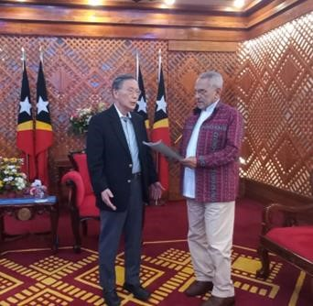
(Photo by Akiko Abe)
President José Ramos-Horta receives the Evaluation Report of Japan`s ODA to Timor-Leste handed over by
Professor Sukehiro Hasegawa

Way Forward for Promoting Inter-Regional Collaboration on Peace with the g7 + Headquarters in Dili
Professor Hasegawa, Professor Mizuno and Ms. Abe also visited the g7+ Headquarters in Dili, TimorLeste and presented the modality for future collaboration to maintain peace in the world and plan for revisiting the current United Nations framework, considering the ongoing conflicts around the world. Strengthening inter-regional safety and security through expanding the network of various regional organizations including g7+ were suggested and discussed for further improving the effectiveness of the role of the United Nations for maintaining world peace and security. Mr. Felix Piedade, Chief Operating Officer of g7 introduced the purpose of making the g7+, an intergovernmental organization that brings together 20 different conflict affected countries representing various regions for sharing of experience, peer learning and to advocate for various reforms on aid effectiveness from international organizations such as United Nations. Today, its mission has expanded to other relevant thematic areas that includes contributing to the security sector reform at the United Nations. The motto for the g7+ is “Goodbye Conflict and Welcome Development.” The current chair of the g7 + is H.E. Francis Kai Kai, Minister of Planning and Economic Development of Sierra Leone and there are many interests shared among various countries in Africa for reforming the United Nations in the security sector. Further continuation of dialogue on this topic was recommended in near future.
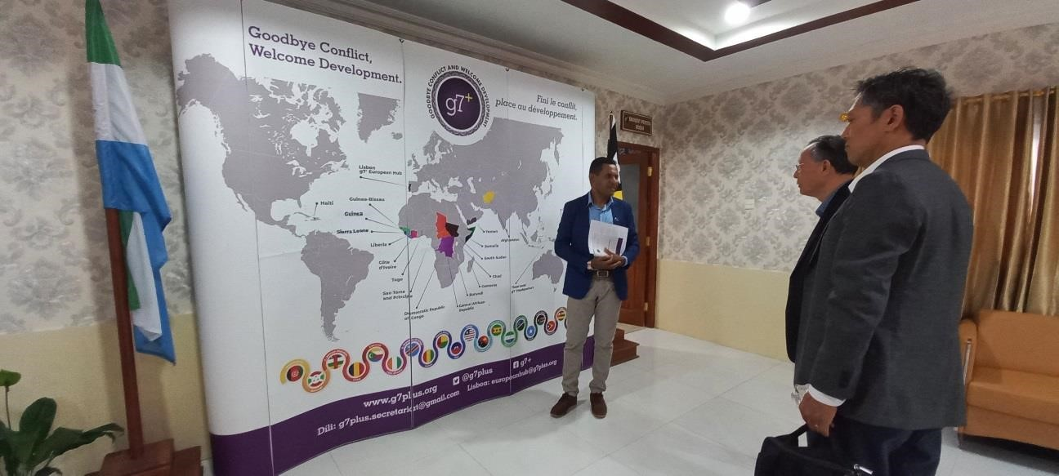
(Photo by Akiko Abe)
Meeting with Mr. Felix Piedade, Chief Operating Officer of G7+

Visits to the UNTL Institute of Technology supported by Japan’s ODA
Japanese civil society delegation also visited the Japan’s Official Development Assistance (ODA) project: Project for the Capacity Development of the Faculty of Engineering, Science and Technology of the National University of Timor-Lorosae (UNTL). After many years of collaboration, many Timorese students had an opportunity to study in Japan for this field. The JICA project team also mentioned further continuation of such technical cooperation as educational exchange programme among two countries is expected and they welcome the support extended by the Government of Japan.
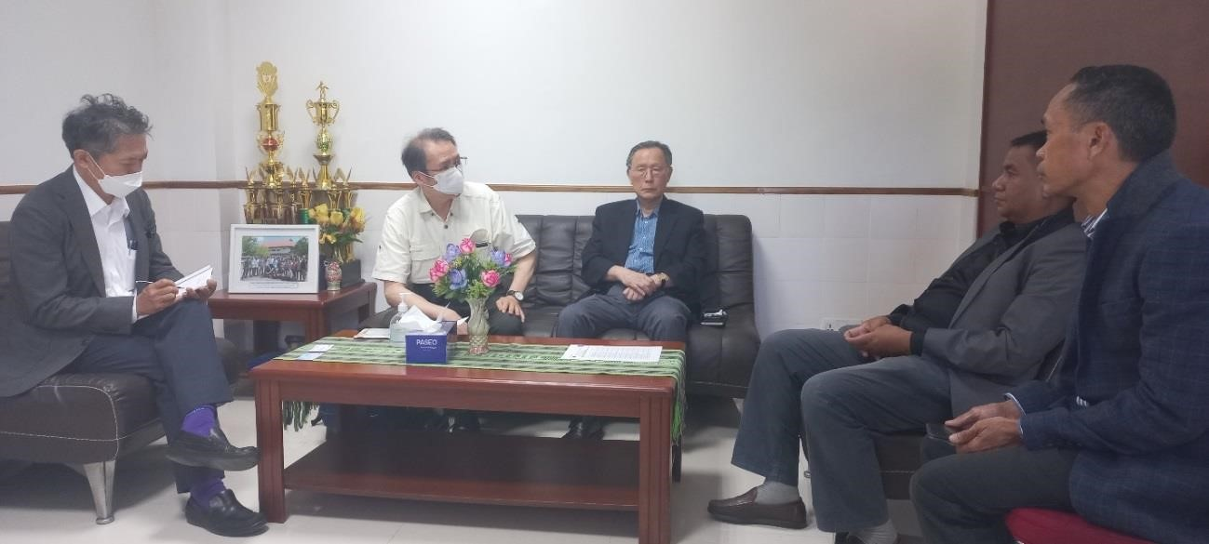
(Photo by Akiko Abe)
Professor Juichi INADA and Professor Takaaki Mizuno along with Professor Sukehiro Hasegawa meet with
Mr. Adalfredo G. DA S. Ximenes, Dean of the Faculty of Engineering of the National University of Timor-Leste

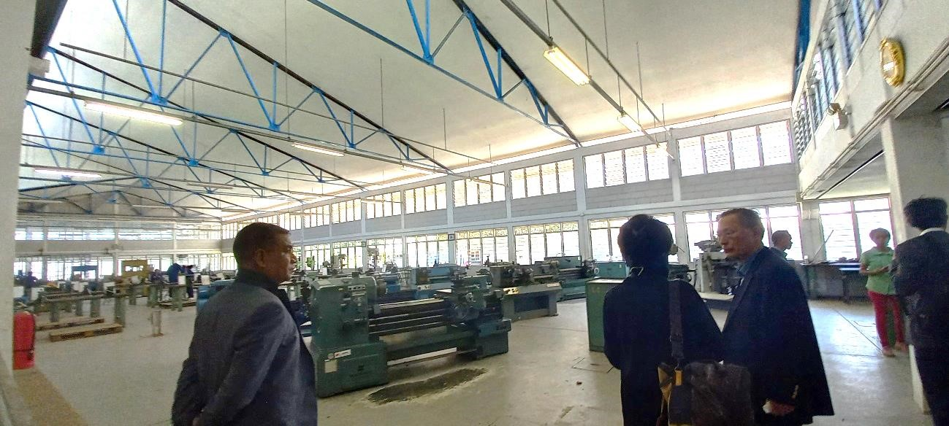

(Photo by Akiko Abe) Visit to Santa Cruz and Shared Commitment towards World Peace from Dili, Timor Leste
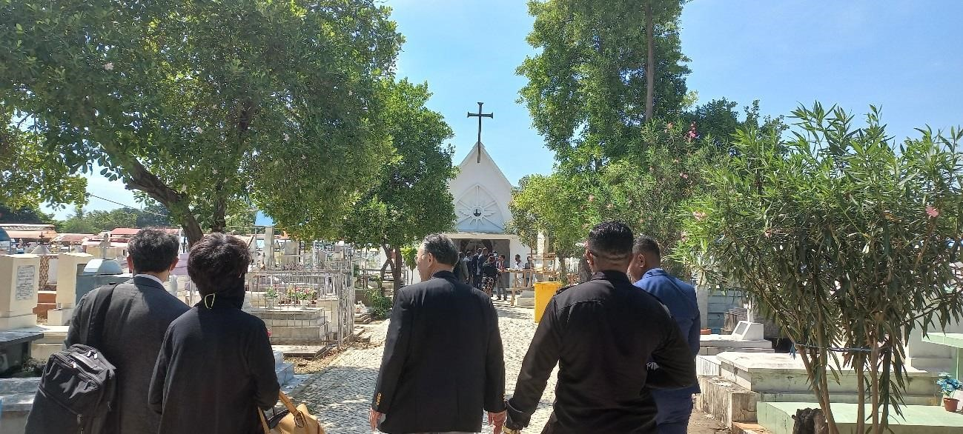
(Photo by Akiko Abe) The delegation also visited the historical site in Timor Leste such as Santa Cruz. The visit was held to commemorate the victims of conflict in the country and share commitment for world peace from Dili,
Timor-Leste, before celebrating the 20th anniversary of the Independence day on May 20, 2022.

Reception by Japanese Ambassador Mr. Masami Kinefuchi
H.E. Ambassador Masami Kinefuchi invited the Japanese delegation and explained the political, economic and social situation in Timor-Leste by sharing the course of friendship built over the last 20 years for the official partnership of the both countries (See more details at https://youtu.be/lzTTKXHuPDc). Ambassador Kinefuchi also shared with Professor Hasegawa the views and understanding of the development taking place in the country. Professor Hasegawa presented the overview of the evaluation of Japan’s ODA to the Timor-Leste (Led by Professor Sukehiro Hasegawa, Professor Mitsuru Yamada, Professor Takeshi Daimon-Sato, Professor Yuji Uesugi, Professor Juichi Inada) and suggested a course of diverse support that Japan could make for the people of Timor-Leste in the years to come. JICA Timor-Leste’s Chief Representative Mr. Ko Goto also welcomed various suggestions made by the Japan’s ODA Evaluation Team’s report published on March, 2022. Ambassador Kinefuchi also emphasized the 20th anniversary of friendship and diplomatic cooperation as strengthened among two countries Japan and Timor Leste and expected further exchange of human resources development in both countries in the years to come.

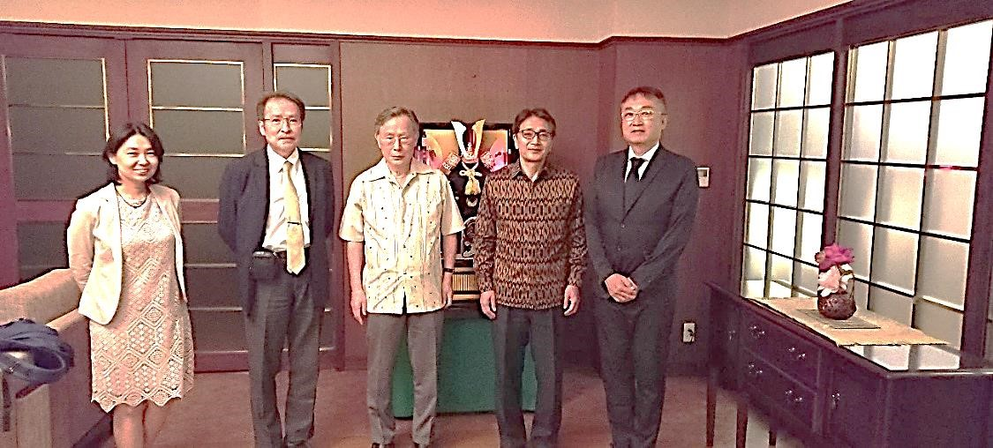
(Photo by Seiko Toyama)
Meeting with Japanese Ambassador Masami Kinefuchi

Meeting with Japanese community in Timor-Leste
The delegation also met with various Japanese professionals continuously working with the people of Timor-Leste for rebuilding the country after conflict and strengthen the social cohesion in the country in humanitarian and development sectors. From the Sister Nakamura working with the people of Timor since 1999 to Director of a local video production in Timor Leste Shinichiro Monjo (the former Japan International Cooperation Agency’s Volunteer (JOCV) and former UNDP consultant) and Ms. Yuu Yoshimori as head of Japanese NGO working in Timor since 2003, a number of Japanese professionals continue to stay with the people of Timor-Leste to continue long lasting friendship and mutual cooperation on the ground. Such human relations and collaboration are indeed the gift from the continued efforts of people of both countries. The delegation has witnessed such strong partnership of the people of Timor-Leste and Japan over these past 20 years.
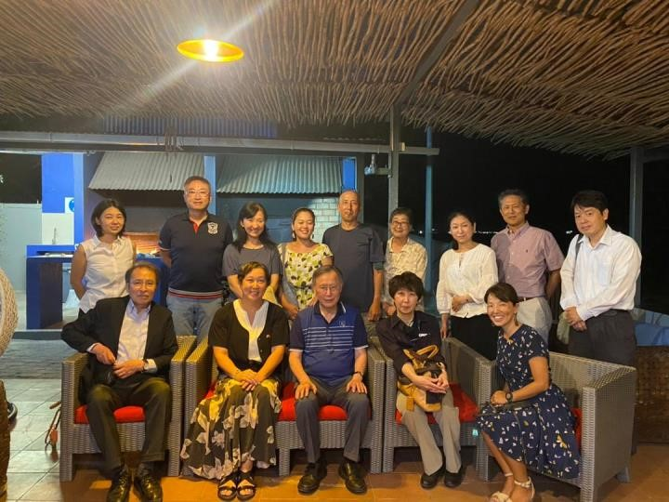
(Photo by the Tito’s)
Meeting with Japanese Community organized by Ms. Seiko Toyama of the Japanese Embassy in Timor Leste
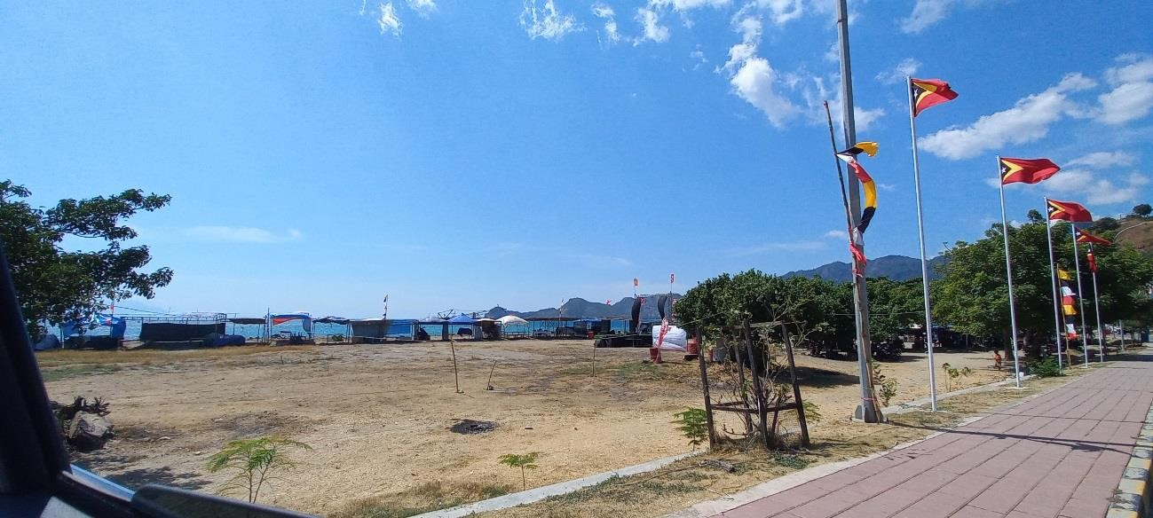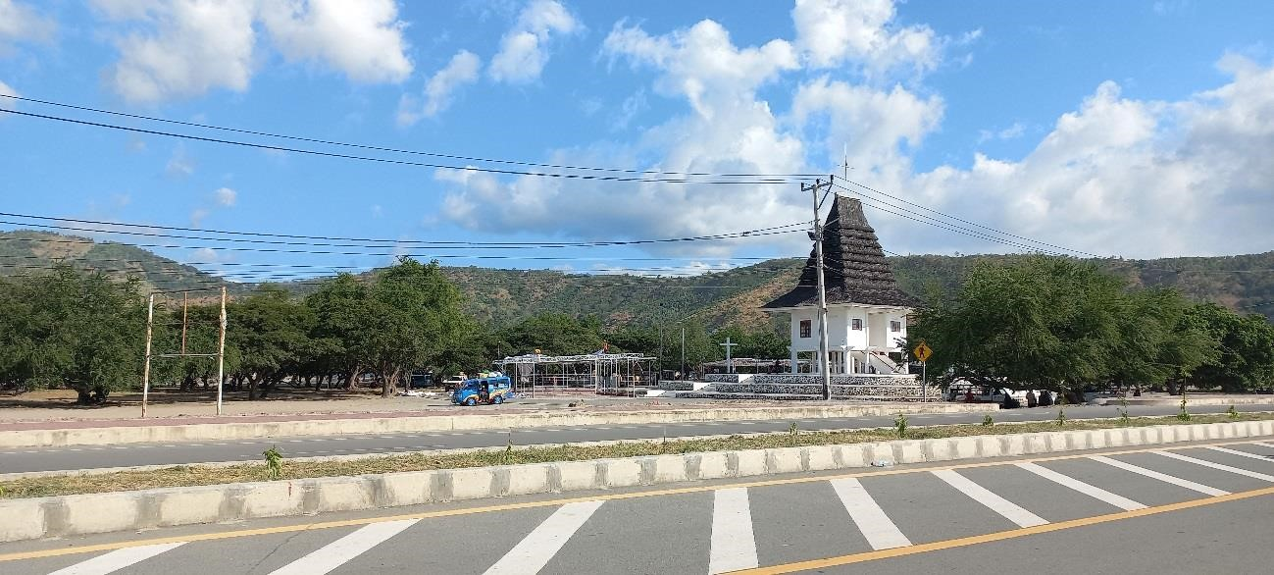
(Photo by Akiko Abe)
*The Inaugural Ceremony of President José Ramos-Horta can be found online at the Youtube https://youtu.be/RAvW9SbWSzs

June 2022: World Refugee Day

